AIM

HRMS User Manual

BANK MUSCAT – HR Project

Recruitment

Description: C:\Users\085\Desktop\All Logo\Oracle-LOGO_PNG.png

Author : Parthasarathy Peruru

Creation Date : 07-Jul-2013

Last Updated :

Version : Version 1.0

1. **Title, Subject, Last Updated Date, Reference Number**, **and** **Version** are marked by a Word Bookmark so that they can be easily reproduced in the header and footer of documents. When you change any of these values, be careful not to accidentally delete the bookmark. **You can make bookmarks visible by selecting Tools->Options…View and checking the Bookmarks option in the Show region.**

**Approvals:**

|  |  |
| --- | --- |
| Approver Name 1 | Navu K |
| Approver Name 2 | Reema Al Jamali |





## Document Control

**Change Record**

7

| Date | Author | Version | Change Reference |
| --- | --- | --- | --- |
|  |  |  |  |
| 07-Jul-2013 | Parthasarathy | 1.0 | Initial Document |
|  |  |  |  |
|  |  |  |  |
|  |  |  |  |

**Reviewers**

| Name | Position |
| --- | --- |
|  |  |
| Navu.K | Project Manager |
| Srinivasan M | Delivery Manager |
|  |  |
|  |  |

**Distribution**

| Copy No. | Name | Location |
| --- | --- | --- |
|  |  |  |
|  | Library Master | Project Library |
|  |  | Project Manager |
|  |  |  |
|  |  |  |

1. The copy numbers referenced above should be written into the **Copy Number** space on the cover of each distributed copy. If the document is not controlled, you can delete this table, the Note To Holders, and the **Copy Number** label from the cover page.

**Note To Holders:**

If you receive an electronic copy of this document and print it out, please write your name on the equivalent of the cover page, for document control purposes.

If you receive a hard copy of this document, please write your name on the front cover, for document control purposes.

Contents

Document Control 1

Introduction 3

Recruitment Process 4

Create Applicant 4

Search Applicants 9

Update Test / Interview Details 11

Create as Employee 13

Open and Closed Issues for this Deliverable 14

Open Issues 14

Closed Issues 14

## Introduction

Recruitment module has been developed, in which, recruitment team can create various Applicant details in the system, and capture the Test / Interview results. Also team would be able to retrieve the Applicant data by various search options. New Applicant data can be created by entering Applicant’s personal details, Employment details, Education details, Test/Interview details.

**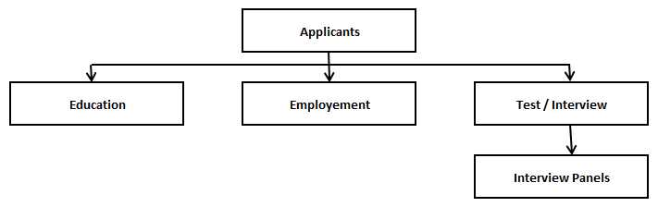**

## Recruitment Process

Following options will be available in oracle recruitment

* **Create Applicant**
* **Search Applicant Profile**
* **Update Test results**
* **Update Interview result**
* **Create Applicant as employee**

### Create Applicant

Using the below navigation, access the Recruitment Search Screen.

Navigation:

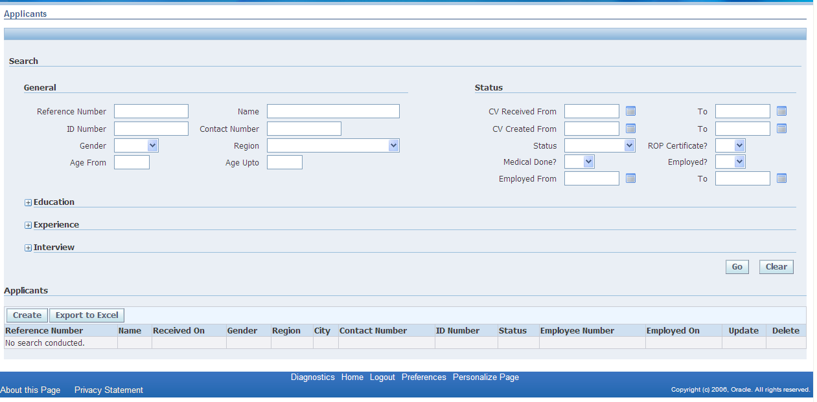

Click “Create” Button, which redirects to a fresh page, where Applicant Details can be captured. Details cover Personal Information, his/her Education details, his/her previous Employment details, Test / Interview Details, and Panel members who conducted the Interviews.

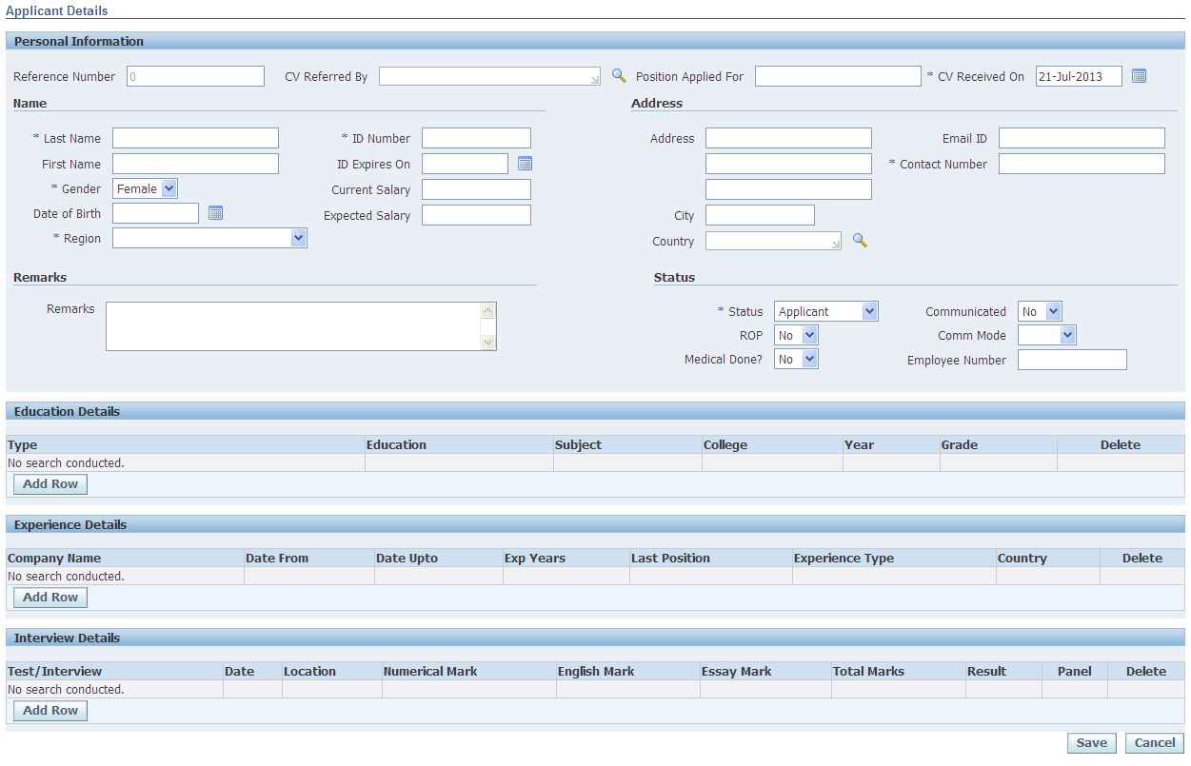

**Personal Information**

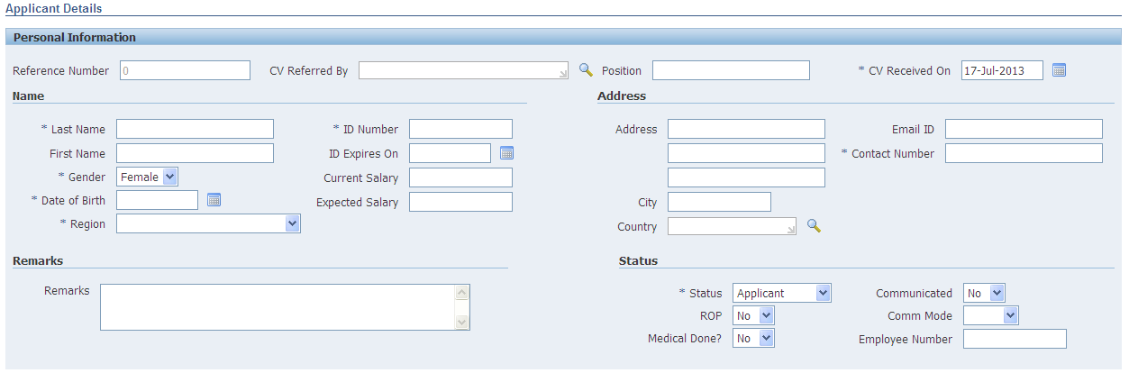

Following are the applicant’s personal details, which captured under “Personal Information”. Each applicants are given a unique Reference Number, which is auto generated by the system.

|  |  |  |
| --- | --- | --- |
| **Sr** | **Column** | **Description** |
| 1 | Reference Number | Unique Number assigned to each Applicant. Auto Generated by System. (However Auto Generation can be stopped using Request Master Setup. In this case user needs to enter the Reference Number).  It is Mandatory |
| 2 | CV Referred By | Capture the Person Name who has referred. If he/she is a Bank Muscat Employee, use LOV icon to capture the Employee Number. |
| 3 | Position Applied For | Free Text to capture for which Position the applicant applied for. |
| 4 | CV Received On | Capture the date on which the CV has been received  It is Mandatory |
| 5 | Last Name | Last Name of the applicant  It is Mandatory |
| 6 | First Name | First Name of the applicant  Optional |
| 7 | Gender | Choose whether applicant is Male or Female  It is Mandatory |
| 8 | Date of Birth | Enter Date of Birth  It is Mandatory |
| 9 | Region | Enter the Region, where the applicant belongs to.  It is Mandatory |
| 10 | ID Number | Capture the applicant’s ID number. It can be ID number issued by Government. For expats, Passport number can be captured.  This also should be a unique  It is Mandatory |
| 11 | ID Expires On | Capture the date on which the ID is expiring. |
| 12 | Current Salary | Capture the current salary |
| 14 | Expected Salary | Capture the expected salary |
| 15 | Address | Capture the Address (3 Address Lines, City, Country) |
| 16 | Email ID | Capture the E-mail ID of the application |
| 17 | Contact Number | Capture the Contact Number  It is Mandatory |
| 18 | Status | Status of the Applicant. Initially this will be “Applicant”, later recruitment administrator can change using the drop down list. |
| 19 | ROP? | Before recruited, applicant has to get “ROP Certificate”. Indicate whether he has received or not. |
| 20 | Medical Done? | Mark whether applicant has completed Medical or not. |
| 21 | Communicated? | In case of “Regret”, Mark whether Communication is sent or not. |
| 22 | Comm Mode | Mode of Communication, Phone, eMail etc. |
| 23 | Employee Number | Once Recruited, assign an unique Employee Number to the applicant. |
| 24 | WHO Columns (Hidden) | System internally maintains Who has Created and When. Also the Last Modified Person and When. |

**Education Details**



Capture the applicant’s Education details

|  |  |  |
| --- | --- | --- |
| **Sr** | **Column** | **Description** |
| 1 | Type | Choose the Type of the Education, like School, Diploma, Graduate, Post Graduate etc |
| 2 | Education | Choose the Education (Degree) from the list |
| 3 | Subject | Choose the Specialization Subject from the list. |
| 4 | College | Choose the College from which applicant has done his education |
| 5 | Year | Year of completion |
| 6 | Grade | Grade in which the education is completed |
| 7 | Delete | Click this button to Delete the entry… |
| 8 | Add Row | Click this “Add Row” button, to add more multiple Education Details |

**Experience Details**

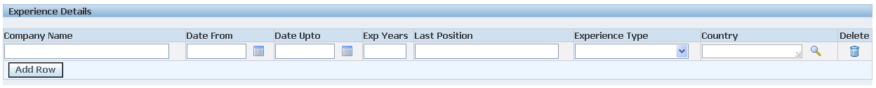

Capture the past Experience Details of the applicant.

|  |  |  |
| --- | --- | --- |
| **Sr** | **Column** | **Description** |
| 1 | Company Name | Capture the Company Name |
| 2 | Date From | Period of experience. |
| 3 | Date Upto | Period of Experience. Leave blank if the applicant is still working in this company. |
| 4 | Exp Years | Experience Years in that company…This will be calculated automatically based on Dates… |
| 5 | Last Position | Name of the Position last held by the applicant |
| 6 | Experience Type | Choose the Type of the Experience |
| 7 | Country | Choose the Country last worked |
| 8 | Delete | Click this button to Delete the entry… |
| 9 | Add Row | Click this “Add Row” button, to add more multiple Experience Details |



**Save**

After capturing all the above information, save the applicant details using Save Button. Reference Number will be generated at the time of Saving.

**Cancel**

Cancel Button will exit from this page and redirected to the Query Page. Also this will rollback the changes done.

### Search Applicants

Once applicant’s details are saved, they can be queried and viewed with various options. Applicant details can be queried based on:

Personal Information

Name wise

ID wise

Contact Number wise

Region wise

Age wise

Date

Creation Date wise

CV Received Date wise

Education

Education Type wise

Education wise

Major Subject wise

Completion Year wise

Past Employment

Position wise

Experience Years wise

Company wise

Experience Type wise

Test / Interview

Tested / Interviewed?

Test / Interview Date wise

Test / Interview Result wise

Marks wise

Panel Member wise

Status

Status wise

Employed or Not

Medical Done or Not

ROP Certificate Received or Not

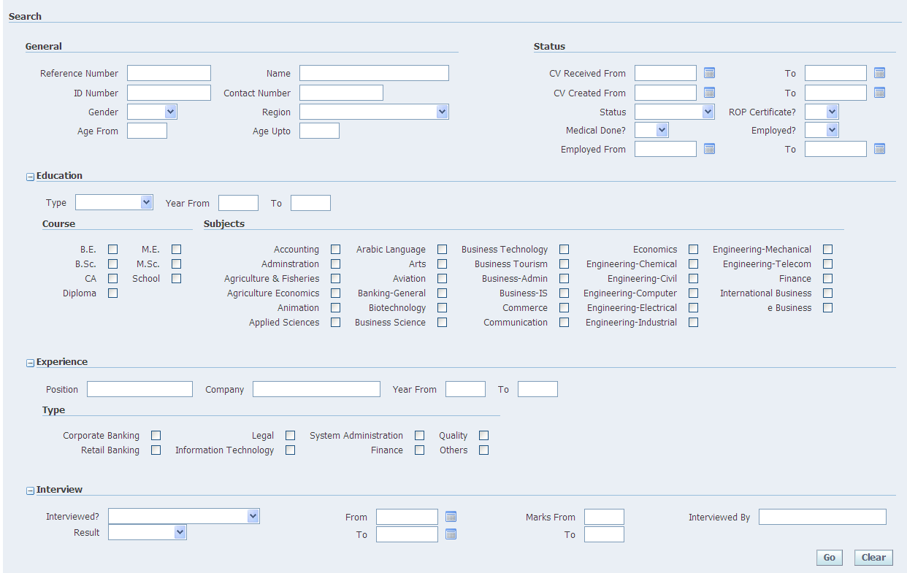

Using below screen, above mentioned Search criteria can be given. After entering criteria, press “Go” button to fetch the applicant data and show results.

Below screen shows the sample query and its results.

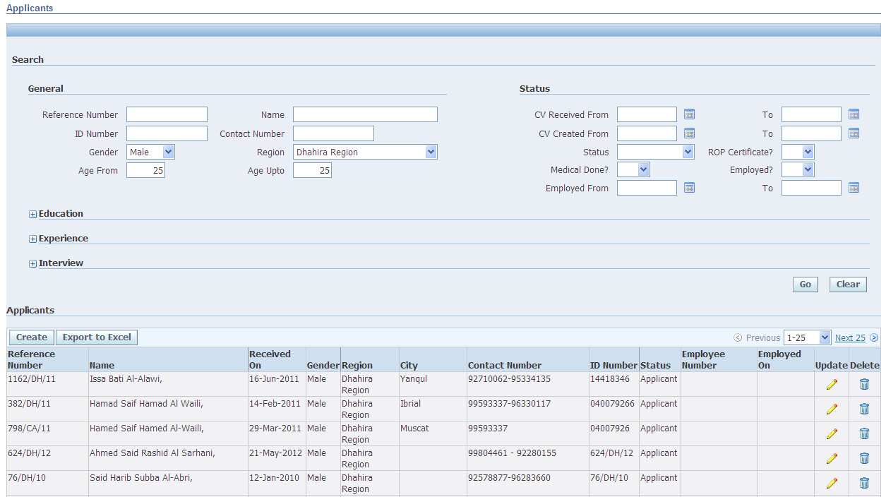

### Update Test / Interview Details

Once Test or Interview are scheduled and completed for an applicant, his/her results can be stored for future reference. Using above search options, query the applicant details. In the results region, press “Update” button to capture Test / Interview details. This will redirect to applicants data screen and in the Interview Details region capture the Test / Interview details.

**Test / Interview Details**



When Test / Interviews are arranged, capture those details and results of the same.

|  |  |  |
| --- | --- | --- |
| **Sr** | **Column** | **Description** |
| 1 | Test/Interview | Choose, whether Test or Interview |
| 2 | Date | Capture Test / Interview Date |
| 3 | Location | Capture the Location, where Test / Interview happened |
| 4 | Numerical Marks | Capture the Numerical Marks (Applicable for Written Test) |
| 5 | English Marks | Capture the English Marks (Applicable for Written Test) |
| 6 | Essay Marks | Capture the Essay Marks (Applicable for Written Test) |
| 7 | Total Marks | Total Mark is calculated automatically. |
| 8 | Results | Choose the Test / Interview Results |
| 9 | Panel | Click this button to capture the Panel Members. This will redirect to another page. |
| 10 | Delete | Click this button to Delete the entry… |
| 11 | Add Row | Click this “Add Row” button, to add more multiple Test/Interview Details |

**Panel Members**

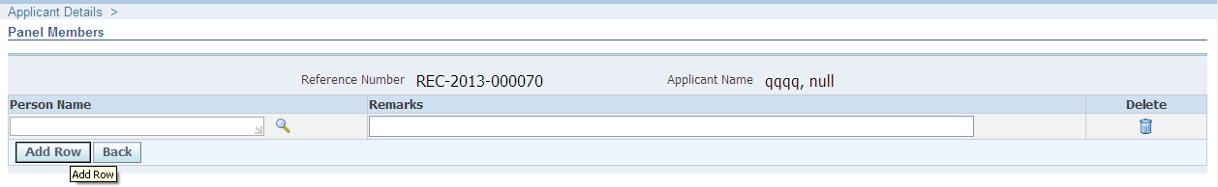

Capture the Panel Members and their remarks.

|  |  |  |
| --- | --- | --- |
| **Sr** | **Column** | **Description** |
| 1 | Person Name | Capture the Person’s Name who has Interviewed. If the Person is employee of Bank Muscat, choose the name from LOV. |
| 2 | Remarks | Capture the remarks mentioned by Panel Member |
| 3 | Delete | Click this button to Delete the entry… |
| 4 | Add Row | Click this “Add Row” button, to add more multiple Panel Members |

### Create Applicant as Employee

After capturing the Test / Interview details, and if applicant’s results are satisfactory, he can be created as Employee in Oracle HR system. For this, below details need to be updated in Applicant’s Status region.

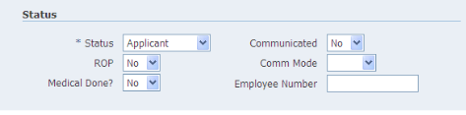

Status - Has to be set as Recruited

ROP - Has to be set as “Yes” or “NA”

Medical Done? - Has to be set as “Yes” or “NA”

Employee Number - Enter unique Employee Number

After setting above status, press “Create Employee” button below the screen, which creates this applicant as Employee in HR System.



***Note:*** *This is done as a future enhancement, and so this option has been disabled currently. This “Create Employee” button will not be visible at this time. However this can be enabled using personalization later.*

## Open and Closed Issues for this Deliverable

1. Add open issues that you identify while writing or reviewing this document to the open issues section. As you resolve issues, move them to the closed issues section and keep the issue ID the same. Include an explanation of the resolution.  
     
   When this deliverable is complete, any open issues should be transferred to the project- or process-level Risk and Issue Log (PJM.CR.040) and managed using a project level Risk and Issue Form (PJM.CR.040). In addition, the open items should remain in the open issues section of this deliverable, but flagged in the resolution column as being transferred.

### Open Issues

| ID | Issue | Resolution | Responsibility | Target Date | Impact Date |
| --- | --- | --- | --- | --- | --- |
|  |  |  |  |  |  |
|  |  |  |  |  |  |
|  |  |  |  |  |  |
|  |  |  |  |  |  |
|  |  |  |  |  |  |

### Closed Issues

| ID | Issue | Resolution | Responsibility | Target Date | Impact Date |
| --- | --- | --- | --- | --- | --- |
|  |  |  |  |  |  |
|  |  |  |  |  |  |
|  |  |  |  |  |  |
|  |  |  |  |  |  |
|  |  |  |  |  |  |